Smart Door Lock Security System using Multimodal System

|  |  |  |
| --- | --- | --- |
| 1Monika Pandey  Computer Science and Engineering Graphic Era Hill UniversityDehradun, India [pandeymonika060@gmail.com](mailto:pandeymonika060@gmail.com) | 2Anshika Agarwal Computer Science and EngineeringGraphic Era Hill UniversityDehradun, India [agarwalanshika75@gmail.com](mailto:agarwalanshika75@gmail.com) | 3Ayushi Dangwal Computer Science and Engineering Graphic Era Hill University  Dehradun, India  [dangwalayushi2001@gmail.com](mailto:dangwalayushi2001@gmail.com) |
| 4Amit Gupta  Computer Science and Engineering Graphic Era Hill UniversityDehradun, India  amitgupta7920@gmail.com | 5Vinay Kukreja  Chitkara University Institute of Engineering and Technology,  Chitkara University, Punjab, India  [vinay.kukreja@chitkara.edu.in](mailto:vinay.kukreja@chitkara.edu.in) | 6Satya Prakash Yadav  Department of Computer Science and Engineering,  G.L. Bajaj Institute of Technology and Management (GLBITM),  Affiliated to AKTU, Greater Noida- 201306, U.P., India.  prakashyadav.satya@gmail.com |

*Abstract*— ***In this paper, there is a quick and trustworthy door locking system method is suggested. The suggested method works effectively for the Advanced Locking system. It includes a fingerprint sensor, iris recognition, and real-time OTP.*** ***Primary goal of this methodology is to produce and deploy an Iris, Fingerprint, and OTP-based door locker security system. Only the authorized person can get papers or money from the lockers using this technology. First-time users of this system must enroll their user’s name, fingerprint, and mobile number. If the user’s name and fingerprint match, the person will be identified and their ID will be stored. Also, a detailed explanation of the technique's benefits and drawbacks is included. We have suggested a "Fingerprint Based Locker Security System" in this article to address the drawback of manual unlocking. The adoption of GSM and fingerprint technology has replaced keys. Since every person has a distinct fingerprint identity, fingerprints are used to confirm a people identify. With GSM technology, the consumer will receive a warning on his mobile device when any unauthorized person enters an inaccurate password.***

Keywords— ***iris image, fingerprint, MATLAB.***

# INTRODUCTION

As an example, the self-service banking system has gained significant popularity in recent years thanks to its ability to provide customers with high-quality assistance around-the-clock. It is extremely common to find ATMs (Automatic Teller Machines) that offer clients the convenience of trading in bank notes.

Nonetheless, there have been an increasing number of incidences of financial fraud in recent years. Often crook’s tamper with ATM terminals and steal the user's password and credit card unknowingly. The criminal will quickly withdraw all the cash when a customer's bank ATM card is lost and the password is stolen. Resulting in severe financial losses for the customer. Maintaining the customer's valid identification has emerged as the top priority in the current financial industry. The recommended solution uses the minutiae matching technique for fingerprint recognition and the Circular Hough Transform for iris recognition. The remainder of this essay is formatted as follows: In Part II, the system development is provided. Part III describes proposed biometric identification methods.

Part IV provides an explanation of GSM technology for OTP generating. Part V mainly focuses on the findings of the experiments. Finally, conclusions are presented in Section VI with the help of comparisons to earlier systems.

# methodology

[6] This section outlines the model implementation process. The proposed system has a fraud detection strategy that uses two biometrics (fingerprint, iris, and OTP) to spot different types of unauthorized entrance attempts as the door is being unlocked. The proposed system aims to use biometric recognition frameworks to increase the security of any door unlocking. For smart access in this system, optical fingerprint sensors are employed. The fingerprint module uses a minutiae-based technique to recognize fingerprints. It matches a person's fingerprint to an actual person's fingerprint that was stored during enrolment. The phrase "VALID PERSON" will appear on the LCD if the user is a legitimate one, according to the controller. The USB camera is utilized to record user.

For iris recognition, a MATLAB GUI built on the Circular Hough Transform is employed. If the person is a genuine user after iris authentication and matching, the controller shows the message "IMAGE IDENTIFIED" on the LCD.

[11] The position and temperature will be continuously monitored throughout this operation, and an LCD message with the words "POSITION:" and "TEMP:" will be displayed.

A 6-character code is texted to the customer's registered cell phone number, which was saved in the database during enrolment, after the person's validation result is true. The GSM 900 module, which connects to the ARM board, is used for this procedure. Regardless of whether the OTP entered is accurate or inaccurate, messages like "CORRECT CODE" or "WRONG" will show. If the check is successful, the door will be opened by a servo motor, and the task will be marked as done on the LCD.

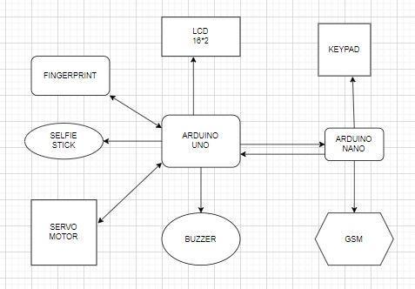

**Figure 1: Architecture of Proposed Model**

# PROPOSED BIOMETRIC IDENTIFICATION TECHNIQUES

## Fingerprint Recognition

[5] The fingerprint image goes through several pre-processing procedures, such as binarization, which decreases the thickness of all ridge edge lines to a single pixel width and utilizes a predetermined threshold to transform a grayscale image into a binary image. An initial code is then generated after that, followed by the protected final code. Five smaller chunks that make up the code block are positioned inside the header and trailer. The five subblock patterns consist of five-minute details that are chosen to be of an appropriate length, for instance, 14 bytes.

Type: It details the points of termination and bifurcation. This parameter is allotted three bytes.

Orientation: Each tiny point is directed in a

specific way. Either clockwise or anticlockwise. For this parameter, two bytes are allotted. Assuming gradients x and y are equal, orientation estimate is provided by = tan-1[g(y)/g(x)]

Spatial Frequency: This parameter describes the separation between the ridges that surround the minutia point. This parameter only receives one byte and is measured in pixels.

Curvature: The pace at which ridge orientation changes

One byte is set aside for this characteristic, which is also measured in pixels.

Position: Describes its x and y coordinates. In relation to the core or delta points, it is calculated. 1 byte devoted to this parameter. the beginning code sequence for these properties result in the generation of 14 bytes, which are stored in the database. To create a secure multifunctional code, this code is later run via the MD5 one-way hash method. When a fingerprint image from the Fingerprint Verification Competition is subjected to a minutia matching technique in

MATLAB, the results will show.

## GSM Technology for otp generation

GENERATION

[4] The global System for Mobile Communication, a digital cellular technology, enables us to deliver voice and data services that work in the frequency bands of 800MHz, 900MHz, 1800MHz and 1900MHz. It communicates using time division multiplexing and has a data rate range of 64kbps to 120Mbps.

The user’s registered cell-phone number received an SMS with the subject “ACCESS CODE” after a successful biometric recognition, and the LCD displayed the message “ENTER THE CODE.” When the vault code was input, the system advanced to the unlocking stage.

But, when the incorrect code was input, the user’s registered mobile phone received an SMS with the subject “UNKNOWN PERSON TRYING TO ACCESS.”

1. GSM MODULE WORKING

When a SMS is received by a GSM modem with a SIM card attached, it sends the information to the microcontroller via serial connection. GSM modem control by AT commands.

1. OTP WORKING

A one-time password is a password that is only good for one transaction.

#### Random Number Generation: Produces a Pseudo- Random Number Sequence.

Assume (YK) YK+1= (a YK +1) mod(m) be the formula.

1. multiplier, seven increasing the m-modulus.

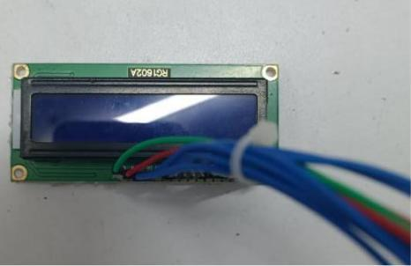

**(a)**

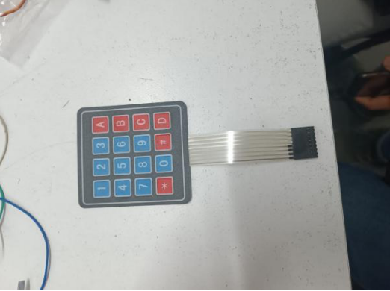

**(b)**

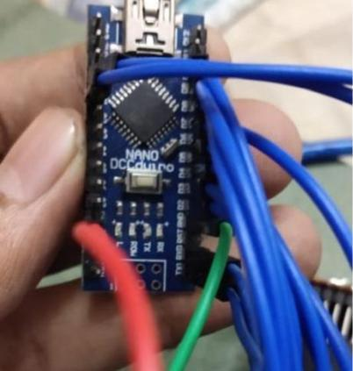

**(c)**

**Figure 2: Hardware used in the model (a,b,c)**

## Iris Recognition

[10] People can be recognised by their irises, which are recognised based on distinctive patterns in the area of the eyeball that surrounds the pupil. The iris has intricate patterns that are evident upon close study and can be brown, blue, grey, or greenish in colour. Iris recognition is regarded as a type of biometric verification because it relies on a biological trait.

A sophisticated, high-resolution digital camera is used in iris recognition to capture any number of fine-grained pictures of the eye at visible or infrared (IR) wavelengths. A matching engine, a specialized computer program, is then used to assess the subject's iris pattern against pictures kept in a database.

At a degree of accuracy like traditional fingerprinting or digital finger scanning, Millions of photographs can be compared in a single second by the matching engine.

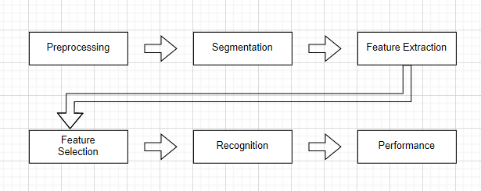

**Figure 3: Steps of Recognition**

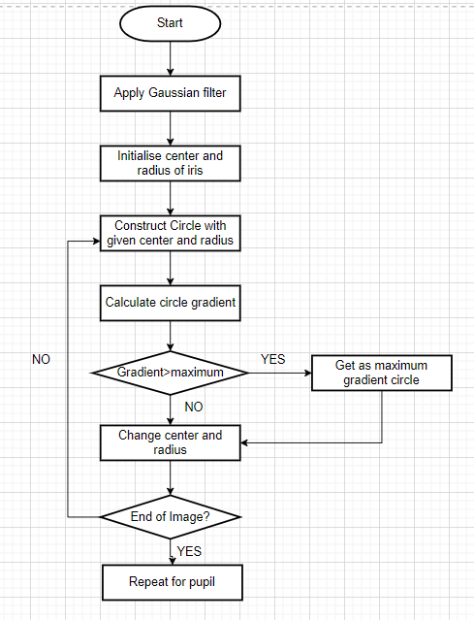

**Figure 4: Flow chart of Iris recognition**

DAUGMAN’S ALGORITHM DESCRIPTION

[2],[13] The process of calculating the radius, iris, and pupil sizes, as well as the center coordinates, is completed using Daughman's equation. The foundation of Daughman's border recognition theory is the following integrodifferential equation:

**𝑚𝑎𝑥 (𝑟, 𝑥0, 𝑦0)|𝐺𝜎(𝑟) *𝜕/𝜕𝑟 ∮ 𝐼(𝑥,𝑦)/2𝜋𝑟 𝑑𝑠|**

If (x, y) denotes the pixel's intensity at (x, y) in the illustration of an iris.

The symbol r designates the radius of several circular areas, and their centers are at (x0, y0).

The standard deviation of the Gaussian distribution is σ.

G stands for Gaussian filter with scale sigma denoted as Gσ(r).

The presumptive center coordinates of the iris are (x0, y0).

S is the circumference of the circle as calculated by the parameters (r, x0, y0).

**Image Acquisition**

The process of creating photographs, such as those of a real-world scene or a room, digital imaging, also referred to as digital image acquisition.

**Image Capture from Industry- Standard**

You can connect scientific and industrial cameras to [12] MATLAB and Simulink using the functions and blocks provided by the Image Acquisition Toolbox. It includes a MATLAB software that allows for interactive hardware property setting and detection. In-the-loop processing, device triggers, standby acquisition, and acquisition coordination across numerous devices are all made feasible with the help of the toolkit.

All major hardware vendors and protocols, including USB3 Vision, are supported by Image Acquisition Toolbox. High-end scientific and industrial equipment, 3D depth cameras, machine vision cameras, and frame grabbers can all be connected.

1. **Converting into Gray Image**

The maximum, minimum, standard deviation, mean, and normally distributed data for all the study's variables were determined using descriptive statistics. The data's normal distribution demonstrates how sensitive the variables are to cyclical fluctuations and speculative thinking.

When data is not distributed properly, it means that the data is susceptible to cyclical swings and speculative movements, which raises the possibility of arbitrage and gives investors the opportunity to profit above average. Yet, the APT makes the premise that there should not be any market arbitrage and that investors can only make typical profits.

Subtract a picture from another or an image from a constant.

Z = subtract (X, Y) returns the difference in the corresponding part in the output array Z after subtracting each component in array Y from its corresponding element in array X. If X is an array of integers, output items.

Fractional numbers are rounded, and values that exceed the boundaries of the integer type are clipped. Process Step:

1. Viewing the background image first, then the main image.
2. Changing both photos' RGB to HSV format.
3. Background and foreground images of a bixoring.
4. Grayscale to RGB conversion.
5. Reading columns and rows of image.
6. Converting it to binary image.
7. Making use of a median filter to eliminate noise.
8. Using boundary labels.
9. Removing noise.
10. **Histogram**

[9] An image histogram is an illustration of a histogram that shows the tonal distribution of a digital image. The number of pixels for each tonal value is plotted. A reader can quickly assess the complete tonal distribution of a picture by quickly scanning the histogram for that image.

Modern digital cameras frequently provide image histograms. Photographers can use them as a tool to show how the tones were distributed and whether image detail had been lost as a result of overexposed or underexposed highlights or shadows. When using a raw picture format, this is less helpful because the presented image's dynamic range might only be roughly equivalent to that of the raw file

1. **Image segmentation**

[1]Image segmentation in computer vision is the division of a digital image into numerous segments (sets of pixels also referred to as super-pixels). By lowering complexity and/or altering a picture's representation, segmentation seeks to improve a picture's meaning and comprehension. Image segmentation, which recognizes objects and boundaries in images, is frequently used (such as lines, curves, etc.). The technique of labelling each pixel in a picture so that identically labelled pixels have similar properties is known as image segmentation.

1. **Cropped Image**

In order to adjust the aspect ratio, emphasize the subject matter, or improve frame, an image is cropped. Depending on the application, this might be done on a real photograph, piece of art, or piece of film, or it might be done digitally with image editing software. The graphic design, publishing, photography, radio, and film industries all engage in this discipline.

1. **Resized Image**

The pixels are printed wider apart or closer together rather than changing the image's pixel count when the print size is changed. Resizing or scaling an image will not change how it appears on the screen. Image Re sampling is the process of changing the image's pixel count.

**Smoothing Image using Gaussian Filter:**

Gaussian smoothing filters are commonly used to produce a less pixelated image.

[3] Use isotropic smoothing kernels of increasing standard deviation to filter the image. It is known as isotropy that Gaussian filters often have equal standard deviations in both directions. A scalar value for sigma can be used to enhance a photo using an isotropic Gaussian filter.

Images with anisotropic Gaussian smoothing kernels can be filtered using Gaussian filtering, however the resulting image might have separate standard deviations along the dimensions of a row and a column. Anisotropic Gaussian filters with axis alignment are what they are known as. When utilizing anisotropic filters, sigma should be specified as a 2-element vector.

**Edge Detection Canny Filter:**

[7],[8] The image processing method known as edge detection finds the edges of objects in images. It works by observing changes in brightness. For picture segmentation and data extraction, edge detection is utilized in the fields of image processing, computer vision, and machine vision.

# CONCLUSION

This paper describes the anatomy of the iris fingerprint, OTP, and password. A thorough history of how it came to be utilized as a biometric characteristic, and a broad foundation for multimodal systems that are currently in use. The primary goal for iris recognition is to give readers a historical overview of several iris recognition methods. This viewpoint leads to the conclusion that while the majority of iris recognition research is comparable, it has mainly concentrated on four key areas: iris segmentation, normalization, which includes Iris template noise reduction, feature extraction, and classification.

references

[1] Amit Gupta, Richa Gupta & Navin Garg (2021) An efficient approach for classifying chest X-ray images using different embedder with different activation functions in CNN, Journal of Interdisciplinary Mathematics, 24:2, 285-297, DOI: 10.1080/09720502.2020.1838060.

[2] Amit Gupta, M.C. Lohani & Mahesh MAnchanda (2021) Financial fraud detection using naive bayes algorithm in highly imbalance data set, Journal of Discrete Mathematical Sciences and Cryptography, 24:5, 1559-1572, DOI: 10.1080/09720529.2021.1969733.

[3] Gupta, R., Tripathi, V., Gupta, A., & Bhatla, S. (2022). Transformation of Medical Imaging Using Artificial Intelligence: Its Impact and Challenges with Future Opportunities. In Soft Computing: Theories and Applications (pp. 201-212). Springer, Singapore.

[4] S. P. Yadav, B. S. Bhati, D. P. Mahato, & S. Kumar, (2022). Federated Learning for IoT Applications. EAI/Springer Innovations in Communication and Computing. Springer International Publishing. https://doi.org/10.1007/978-3-030-85559-8 .

[5] S. Vikrant, P. R. B, and B. H. S, “Policy for planned placement of sensor nodes in large scale wireless sensor network,” KSII Trans. INTERNET Inf. Syst., vol. 10, no. 7, 2016, doi: 10.3837/tiis.2016.07.019.

[6]S. P., Mahato, D. P., & Linh, N. T. D. (2020). Distributed Artificial Intelligence and IOT (S. P. Yadav, D. P. Mahato, & N. T. D. Linh, Eds.). CRC Press. https://doi.org/10.1201/9781003038467

[7] Sharma, Rishabh, and Vinay Kukreja. "Rice diseases detection using convolutional neural networks: a survey." In 2021 International Conference on Advance Computing and Innovative Technologies in Engineering (ICACITE), pp. 995-1001. IEEE, 2021.

[8] Kukreja, V., Sakshi Machine learning models for mathematical symbol recognition: A stem to stern literature analysis. Multimed Tools Appl 81, 28651–28687(2022). https://doi.org/10.1007/s11042-022-12644-2

[9] V. Kukreja and D. Kumar, "Automatic Classification of Wheat Rust Diseases Using Deep Convolutional Neural Networks," *2021 9th International Conference on Reliability, Infocom Technologies and Optimization (Trends and Future Directions) (ICRITO)*, Noida, India, 2021, pp. 1-6, doi: 10.1109/ICRITO51393.2021.9596133.

[10] Sakshi, S. Lodhi and V. Kukreja, "Deep Neural Network for Recognition of Enlarged Mathematical Corpus," *2022 International Conference on Decision Aid Sciences and Applications (DASA)*, Chiangrai, Thailand, 2022, pp. 411-415, doi: 10.1109/DASA54658.2022.9764978.

[11] P. Goyal, A. K. Sahoo, T. K. Sharma, and P. K. Singh, “Internet of Things: Applications, security and privacy: A survey,” *Mater. Today Proc.*, vol. 34, pp. 752–759, 2019, doi: 10.1016/j.matpr.2020.04.737.

[12] V. Vimal, T. Singh, S. Qamar, B. Nautiyal, K. Udham Singh, and A. Kumar, “Artificial intelligence-based novel scheme for location area planning in cellular networks,” Comput. Intell., vol. 37, no. 3, pp. 1338–1354, 2021, doi: 10.1111/coin.12371

[13] L. Mohan, J. Pant, P. Suyal, and A. Kumar, “Support Vector Machine Accuracy Improvement with Classification,” in Proceedings - 2020 12th International Conference on Computational Intelligence and Communication Networks, CICN 2020, 2020, pp. 477–481, doi: 10.1109/CICN49253.2020.9242